Beef Ordering Information
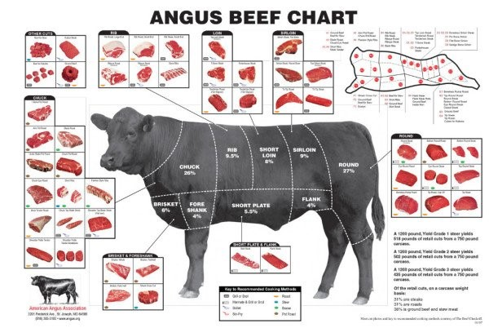
We offer your choice of a Quarter, Half, or Whole beef.

Our beef is priced at $6.00 per pound and charged based on the hanging weight. Hanging weight is the weight after the processor has removed head, hooves, organs, and hide. The Processor gives me the hanging weight. A calf will dress between 55% and 65%, with the average being around 60%.

The amount of beef you will take home from the processor is 55% to 65% of the dressed weight, and averages about 60% of the dressed weight.

Example: A 1,000 pound calf at 60% of the live weight would be 600 pounds. 60% of the dressed weight would be 360 pounds. 360 pounds is the average amount of beef you would plan to take home from the processor for a whole beef. Half beef will be approximately 180 lbs and quarter beef will be approximately 90 lbs.

A final take home price for the beef including the processing fees will average around $7.00 to $8.00 per pound. *Prices and weights may vary.*

Keep in mind we are talking about averages of live weight and dressed weight. The individual cuts of meat you choose will play a part in how many pounds are taken home due to some cuts are bone in and others are bone out.

If you order a Half or Whole beef, you will be able to choose how the calf is cut up. If you order a Quarter the cuts will be from a standard cut order provided. The Hamburger will be approx. 85/15. Approximate take home percentages are 35% Ground, 35% Roasts, 15% Steaks, 15% Other/Miscellaneous.
How much freezer space will you need for the different sizes? About 1cu. ft of freezer space for each 25lb of beef, so for a whole beef you will need a 14cu ft freezer space, half a 7 cu ft, and a quarter a 3.5 cu ft.

Once your order is placed you will be added to the next available processing date. The calf will be delivered to the processor by us. You will then notified of drop off at the processor. And pickup/delivery options will be discussed at this time. We use Keys Family Processing in Van Buren, AR (with the exception of a few processing dates here and there). Keys Family Processing is a USDA inspected facility.

We will send you an invoice via e-mail for your nonrefundable deposit for the Quarter, Half, or Whole. Payment will be due on receipt of our invoice. If you do not have e-mail we can mail the invoice to you via the Post Office. Entire payment (minus deposit) is due in full before the beef is delivered/picked up.

Look over the Custom Beef Order Form to get an idea of the options of how you want your beef cut up, and in what size packages, (For Half or Whole). We will help advise you on different cuts to maximize your individual family needs. When completed, we will leave the form with the Processor for you when the calf is dropped off.

The processor figures the processing fees, by the hanging weight. I include the processing fees in the $6/lb fee. The beef is normally aged for 14 days before processing. It takes approximately 18-21 days for the aging, processing, packaging, and freezing to be completed.

We will pick up the frozen beef from the processor for you unless other arrangements are made, then notify you when your beef is ready and schedule a time to pick up your custom beef at specific location (such as Farms to Families FOOD HUB in McDonald County, MO or we also free delivery from the processor to your home within 40 miles of Wesley, AR.

